

**VCJC Fair and Impartial Policing Subcommittee**

**Minutes March 10, 2023 10:00-Noon**

**Meeting Date:** 10-Mar-23 10:00

**Participants**

In Attendance [Firpo, Jennifer](mailto:Jennifer.Firpo@vermont.gov)

In Attendance [Garces, Amanda](mailto:Amanda.Garces@vermont.gov)

In Attendance [Davis, Xusana](mailto:Xusana.Davis@vermont.gov)

In Attendance Tabitha Pohl-Moore

In Attendance Gregg J[ager](mailto:gjager@southburlingtonpolice.org)

In Attendance Karen Tronsgard-Scott

In Attendance [Park, James](mailto:James.Park@vermont.gov)

In Attendance [Boyde, Glenn](mailto:Glenn.Boyde@vermont.gov)

In Attendance [Kessler, Barbara](mailto:Barbara.Zonay@vermont.gov)

In Attendance [Rachel Lawler](mailto:yoon.yunshil@gmail.com)

In Attendance [Simons, Heather](mailto:Heather.Simons@vermont.gov)

In Attendance [Thompson, Julio](mailto:julio.thompson@vermont.gov)

In Attendance [Jacobsen, Erin](mailto:Erin.Jacobsen@vermont.gov)

In Attendance [Lueders-Dumont, Timothy](mailto:Timothy.Lueders-Dumont@vermont.gov)

In Attendance Lia Ernst

In Attendance Madeleine Sharrow

In Attendance Will Lambek

In Attendance Ann Schroeder

In Attendance Justin Stedman

In Attendance Jose Ignacio

In Attendance Rossy Alfaro

In Attendance Emilio Morales

# Notes

Meeting notes recorded by Xusana Davis.

Meeting called to order at 10:04 a.m.

**Agenda**

1. Call to Order: Chair Garces
2. Introductions
3. Approval of Meeting Minutes of January 13, 2023
4. Public Comment
5. FIP Policy Report Back – AG’s office
6. FIP Policy – Next Steps
7. Motion to adjourn

**Approval of January 13, 2023 Minutes**

* Motion to approve: Karen TRONSGARD-SCOTT
* Second: Justin STEDMAN
* Vote Outcomes: All vote aye. Result: Minutes approved.

**Public Comment**

Public comment was provided throughout the meeting and is reflected in the discussion notes below.

**FIP Policy Feedback from Office of the Attorney General**

The Office of the Attorney General (AGO) has spent several years generating feedback on the various proposed modifications to the FIP policy. Today, Erin JACOBSEN will present the AGO's reflections on the updates proposed by Migrant Justice and the ACLU (MJ/ACLU). A visual chart of each proposal appears below each.

* **Section VI.f.**: AGO is not proposing changes to the granting language, but recommending addition of subsections 2 & 3 to ensure law enforcement agencies (LEAs) are not providing access to their facilities for ICE detention/interviewing/enforcement activities. AGO agrees they don't want LEAs turned into holding cells for ICE/CBP and thinks that should be reflected In the FIP policy. However, AGO was concerned by the MJ/ACLU proposal for the following reason: A law enforcement officer (LEO) is conducting a valid traffic stop and an ICE agent arrives. If the policy is that the LEO is not supposed to grant ICE access to the person, how is the LEO expected to react? How far should the LEO go to not grant access: physically block the agent, for example? AGO says policy should be clear about what LEOs are expected to do and not do.
  + Tabitha POHL-MOORE: There is a difference between policy and procedure in LEAs. If there is a concern about behavioral or procedural expectations of LEOs, could that be further clarified in LEA procedure?
    - JACOBSEN: Yes, and a lot of this will require training, especially regarding immigration laws, what happens when non-citizens are arrested, how it impacts families, etc. This might be helpful to clarify behavioral risks and expectations.
  + Will LAMBEK: The language proposed by MJ/ACLU that states "shall not grant agents access" was already the policy approved by the VT Criminal Justice Council (VCJC) and was in place for about a year before the change in presidential administration in 2016/2017.
    - TRONSGARD-SCOTT: Was this change in 2016/2017 done as a result of changes to federal immigration laws? If so, have those federal laws since been updated?
      * LAMBEK: The current "Propose granting" language in Vermont was added in 2017 to weaken this FIP policy in response to the election of former President Trump after his administration began threatening harsher immigration policy.
  + Lia ERNST: It is unreasonable for LEOs to be expected to engage in physical conflict with ICE agents, but it is reasonable to expect them to insist that an ICE agent produce a warrant if the agent wants access to the person in question.
    - JACOBSEN: ICE still has arrest powers without an administrative warrant. It would be difficult for LEOs to discern the difference between valid federal warrants and invalid ones.
  + Emilio MORALES: We often go out on errands or other routine activities and have a deep fear of being stopped or detained by immigration agents. We aren't doing anything wrong or bad, just everyday activities, but there is a persistent worry that we will be detained in scenarios like these.
  + Gregg JAGER: There should be a distinction between roadside provisions and facility provisions., especially if LEOs are expected to make legal decisions/analyses regarding the validity of administrative warrants in the moment during a traffic stop.
    - LAMBEK: Subsection 1 is already about roadside policy because subsections 2 and 3 are about facilities, correct?
      * JACOBSEN: That's correct.
  + LAMBEK: We also don't want to see bad actors exploit loopholes like what we saw in Orleans County, where LEOs were being coached on the roadside stop on how to say the "magic words" to allow ICE access.

* **Section V.b.**: AGO's recommendation further modified the MJ/ACLU proposed language by making the language more permissive (specifically changing "shall" to "should" in certain places). AGO also proposes adding English proficiency and "formal documentation" as factors that LEOs are not permitted to use as establish reasonable suspicion of a criminal offense.
  + LAMBEK: Can you provide an example of a scenario of LEAs needing to investigate unlawful entry as a risk to public safety that wouldn't already be covered by existing provisions granting LEOs authority to investigate other threats to public safety?
    - JACOBSEN: There may be suspicions of trafficking that aren't certain, but that there needs to be more investigation. We want to limit this to valid public safety concerns, not pretextual actions (because that would violate the FIP policy, of course). If we can’t find meaningful justification for having this provision, AGO might be open to considering withdrawing this modification.
      * ERNST: Reasonable suspicion is a low bar, so if that's the standard for whether LEOs can investigate immigration matters, that's all the authorization they'll ever need. Where vagueness is entered into the policy, that's where we see the more egregious cases. Absent a glaring justification for including it, there's no reason to make this modification because the MJ/ACLU proposal is already clear and clean.
  + IGNACIO: In my household, several of us travel in a vehicle together, sometimes 5 or 6 of us at a time. We have a fear that LEOs will stop us because they see a full vehicle and assume we are crossing the border. We want to see this policy updated to reflect that this kind of behavior by LEOs is not permitted.
    - Barb KESSLER: Traveling in a car is not a threat to public safety, so LEOs shouldn't be using it as pretext. However, subsection 2 must be broad and should be kept as recommended by AGO because it gives the necessary discretion for LEOs to investigate when there is a genuine concern about threat to public safety.
      * ERNST: Clarifying there is no proposal on the table that suggests LEOs can't investigate a public safety concern. Rather, the MJ/ACLU proposal is to prevent LEOs from investigating federal immigration violations based on the idea of threat to public safety.
        + LAMBEK: That's correct, and we saw this happen before: A Chittenden County LEO stopped a car that had two White women and two men who had limited English proficiency and who "averted their gaze" and allowed the White women to speak on their behalf. This justification was used by the LEA until it was subject to review and enforcement by the Vermont Human Rights Commission in a finding of unlawful discrimination.

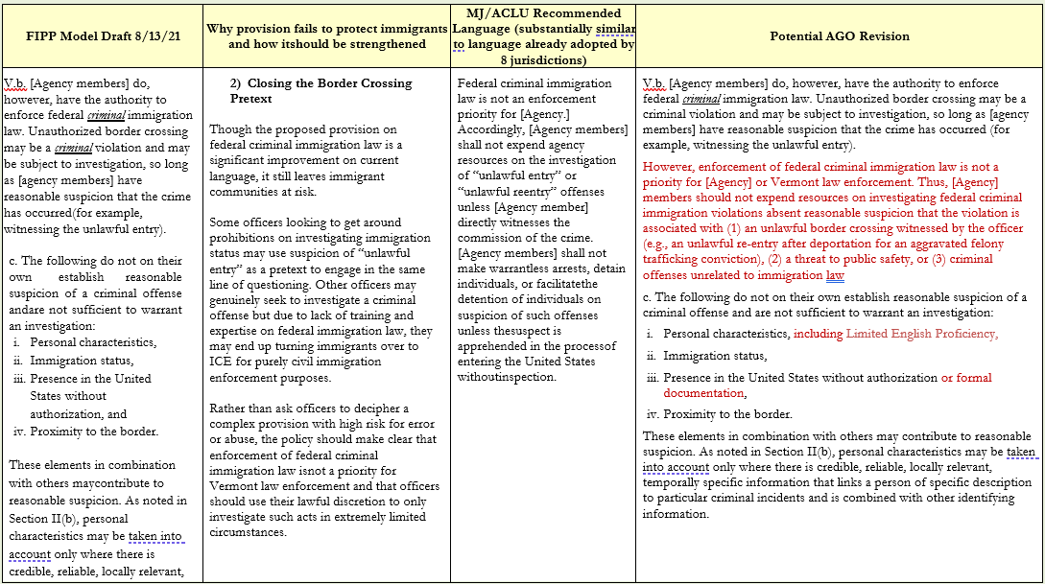



* **Sections V.d.iii. and II.c.**: AGO recommends adding "immigration status" to the list of factors that LEOs cannot use as a reason to arrest or detain people. It also adds a provision that LEOs may not presume "that the mere fact that someone is undocumented means they present an increased risk of flight."
  + POHL-MOORE: Can we also update the AGO recommendation for subsection II.c. to include language proficiency as another factor?
    - JACOBSEN: Yes, we would agree to add that.
  + LAMBEK: Can you provide an example of a time where immigration status would be a relevant factor to determine flight risk? For example, in Rule 3 determinations, one of the factors considered is whether the person has ties to the community. Sometimes, the existence of the person's student visa is used as a factor impacting their community ties.
    - JACOBSEN: This factor can be helpful to know alongside other facts, so we want to allow for situations where it may be relevant to making a valid arrest, but we want to avoid scenarios where it's used to determine whether a person is a flight risk.
    - LUEDERS-DUMONT: Agree that this factor alone should not be used, but it is often the case that living in VT is helpful to a person's case when determining flight risk, so it is helpful to keep.
  + LAMBEK: In the AGO's recommended change to II.c., does the word "alone" modify both "immigration status" and "personal characteristics," or just immigration status?"
    - JACOBSEN: Just "immigration status."
      * LAMBEK: This is why it's dangerous to include either of these factors at all, because then personal characteristics like speaking with an accent or nationality will be used in these sorts of determinations.

* **Section VI.h.**: This section is about information sharing and AGO did not see much opportunity to make changes here other than to add an explanatory note about VT not prioritizing immigration enforcement. AGO sees the MJ/ACLU proposed update as in conflict with 8 U.S.C. §1373 and 8 U.S.C. §1644.
  + ERNST: ACLU believes 8 U.S.C. §1373 is unconstitutional. Despite the ruling supporting it, that decision was an outlier in the broader landscape of similar cases. Understanding the AGO doesn't want to propose changing state law in a way that violated federal law, the changes in the MJ/ACLU proposal do not implicate this federal statute, but have a big impact in people's lives and cases in VT. Besides, there is an extremely low likelihood of repercussions if VT were to be found to have violated this federal statute. The nine VT jurisdictions that have adopted this policy have not experienced any repercussions as a result of adopting this policy.
    - LUEDERS-DUMONT: Agree that the Second Circuit is very much an outlier on this point, even when compared against other conservative courts that have decided on this. Most of the other federal circuit courts that have considered this have been considering it in the context of the Bern issues, and have not revisited it since then and the U.S. Supreme Court (SCOTUS) is not looking at taking up this issue.
      * LAMBEK: Agree that SCOTUS will not likely take this issue up because the federal government has changed its position under the current presidential administration. Since the federal government has stopped asking states to certify compliance, there is no reason for states to bring a case claiming harm by the policy.
  + JACOBSEN: VT state law has a provision that states that to the extent state law conflicts with these federal provisions, the state law is abolished.
    - ERNST: ACLU does not believe there are any lawful requirements of 8 U.S.C. §1373, so there would be no violation of the state law if this proposed change were made.

* **Section VI.**: AGO recommends adding clarifying language to the proposed MJ/ACLU updates.
  + The discussion around these proposed changes mirrored/continued the conversation about the previous set of recommendations for Section VI.h.

**Next Steps**

* The group will return for its next meeting on April 10th. Subcommittee members will be prepared with questions and feedback after reviewing the proposals discussed at this meeting.
* Migrant Justice will provide any additional questions or feedback to the group within 2 weeks.
* The subcommittee will vote at its next meeting and present its findings/recommendation to the broader VCJC afterwards.

**Adjourn**

* Motion to adjourn: POHL-MOORE
* Second: TRONSGARD-SCOTT
* Vote Outcomes: All vote aye. Meeting adjourned at 11:59 a.m.
* Next Meeting Date: April 10, 2023 (10:00-12:00)

**Materials Shared/Presented**

* Attorney General proposed revisions to FIP policy
* Text of Rule 3: [Rule 3](https://casetext.com/rule/vermont-court-rules/vermont-rules-of-criminal-procedure/ii-preliminary-proceedings/rule-3-arrest-without-a-warrant-citation-to-appear)